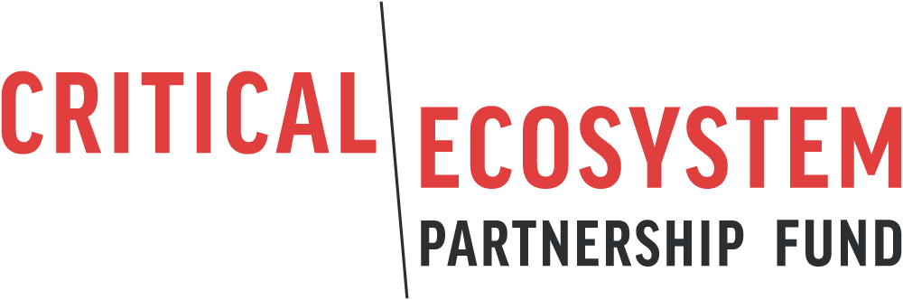
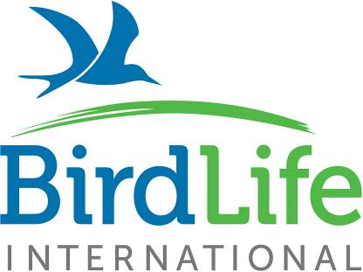

Mediterranean Basin Biodiversity Hotspot
Letter of Inquiry for Small Grants

Project Title:

LOI INSTRUCTIONS

The Critical Ecosystem Partnership Fund (CEPF) enables civil society to protect the world’s biodiversity hotspots. CEPF funding opportunities are announced via calls for proposals. Please refer to the call for proposal document for full details on the eligibility criteria.
BirdLife International, as the regional implementation team for the region, facilitates the CEPF Small Grants programme in the Mediterranean Basin. Successful applications will be contracted as a small grant, with an agreement made between the organization and BirdLife International.
This letter of inquiry (LOI) form is the first stage of the application process. Please complete all sections before you submit your application. The review process will take approximately eight weeks from the closing date. All applicants will be notified of the status of their LOI and successful applicants invited to the second stage.
Before applying, applicants are encouraged to discuss project ideas and eligibility with the programme officer for your region:
- Balkans Small Grant Coordinator, Milica Mišković: milica.miskovic@pticesrbije.rs
- Middle East Programme Officer, Sharif Jbour: sharif.jbour@birdlife.org
- North Africa Programme Officer, Awatef Abiadh: awatef.abiadh@lpo.fr
- Cabo Verde Programme Officer, Harriet Pinder: harry.pindercepf@gmail.com

To submit your LOI, please send this completed form and any attachments, by the deadline, to CEPF-MED-RIT@birdlife.org.
If you have any general queries, please email CEPF-MED-RIT@birdlife.org or visit our website: www.birdlife.org/cepf-med.
SECTION 1: ELIGIBILITY
CEPF funds may not be used:
- to directly fund government agency activities
- for the purchase of land
- for the involuntary resettlement of people
- for the capitalization of a trust fund
- for the alteration of any physical cultural property
If your proposed project involves any of the above ineligible activities, CEPF is not in a position to fund your proposal. Where possible, you may revise your strategy to avoid these elements. Please seek advice from the regional implementation team before proceeding with your application: CEPF-MED-RIT@birdlife.org.

Please answer the following questions:
Do you represent, or is your organization controlled by, a government agency?
☐ YES ☐ NO
If yes, can you demonstrate that your organization:
- Has a legal personality independent of any government agency or actor? ☐ YES ☐ NO
- Has the authority to apply for and receive private funds? ☐ YES ☐ NO
- May not assert a claim of sovereign immunity? ☐ YES ☐ NO

Do you plan to use any of the potential project funds to purchase land?
☐ YES ☐ NO
Does the project involve the relocation of people or any other form of involuntary resettlement?
☐ YES ☐ NO
Do you plan to use any of the project funds to capitalize (a) trust fund(s)?
☐ YES ☐ NO
Does the project involve the removal or alteration of any physical cultural property (includes movable or immovable objects, sites, structures, and natural features and landscapes that have archaeological, paleontological, historical, architectural, religious, aesthetic or other cultural significance)?
☐ YES ☐ NO

SECTION 2: ORGANIZATION INFORMATION

Applicant Organization Name
Write the name of the organization as stated in the legal registration certificate.

Short Name/Acronym (if any):

Physical Address:
Where your office is located, if different from mailing address below. Please include the country in which your office is located.

Mailing Address (if different from the above):

Official/General Email Address:

Name of Project Lead:
Provide the name for the person responsible for correspondence with the RIT regarding this project.

Position in Organization:

Email Contact of Project Lead:
Provide an email address. The RIT will use this email address to communicate with you.

Telephone (include country code)
Provide a number for the office and for a mobile phone of the project lead contact, if available.

Website Address (if any)

Other Social Media Web Addresses (i.e., Facebook, Twitter, etc.)

Staffing:
Please provide the number of people that work for the organization in the relevant category.
Permanent staff: Part-time staff: Volunteers:

Organization Type:

___ Local/National ____ International

Year Organization Established:

History and Mission Statement (maximum 200 words)
Provide a brief description of your organization’s history and mission, including experience relevant to the proposed project.

SECTION 3: BASIC PROJECT INFORMATION

Project Title:

Project Duration: in months
Project Summary: (50-75 words)

Project Location: Define the geographic location where project activities will take place.

Country(s):
Key Biodiversity Area(s): if relevant
Catchment Management Zone or Corridor: if relevant
Map/location: Include a map of your proposed project site below or in a separate attachment; provide a link to an appropriate Google Earth map; or indicate its latitude and longitude here.

Strategic Direction: State the CEPF strategic direction that this project will contribute to.

Investment Priorities: Please state the investment priority/ies that this project will address.

Link to CEPF Investment Strategy (150 - 300 words)
Explain how this project contributes to the CEPF strategic direction and investment priorities.

SECTION 4: PROJECT DESIGN

Project Rationale – (Max 250 words)
Describe the conservation value of the area you plan to work in and its importance for biodiversity and people, and explain the problem your project is addressing.

Project Approach – (Max 250 words)
Describe the proposed strategy and actions of the project in response to the conservation need stated above, including a summary of project objectives, components, and key activities you would like to carry out.

Project Short-term Impacts – (Max 150 words)
Describe the anticipated conservation impacts as a result of your proposed project activities (the direct short-term benefits e.g. to species, habitats, people).

Project long-term Impacts – (Max 150 words)
Describe how the results will contribute to conservation of biodiversity beyond the life of the project (e.g., sustainability, replicating the activities or the outcomes, social impact etc.)

Project Risks – (Max 150 words)
Describe any potential risks you may face in implementing your project (e.g., environmental conditions, civil unrest, government policies, beneficiaries unwilling to try new techniques). Please explain how you intend to minimize the risk.

Project Partners – (Max 150 words)
List all partners that will be directly involved in implementing this project with a key role and responsibility (e.g., another conservation organization, consultancy, etc. For each one, describe their anticipated role).

Project Stakeholders – (Max 150 words)
List all stakeholders that will be involved in this project (e.g., local school, university, government agency, local businesses, other NGOs, etc.) For each one, describe their anticipated role.

SECTION 5: SAFEGUARDS
The following questions help CEPF determine if your project triggers any social or environmental safeguards. CEPF is required to assess all applications to determine if safeguards are triggered, and if any appropriate mitigation measures need to be included in project design and implementation. For further information on safeguards, please visit https://www.cepf.net/grants/before-you-apply/safeguards.

- Please answer the questions below – Tick all boxes that apply:
To the best of your knowledge, please tick if your project will involve any of the activities below.
Does your project …
☐ Support construction or rehabilitation?
☐ Support forestry activities?
☐ Have indigenous people present in or around the project site?
☐ Have any adverse impacts on local communities?
☐ Strengthen the management of a Protected Area?
☐ Restrict access to resources in a Protected Area?
☐ Remove or evict anyone?
☐ Use pesticides or any other type of poison?
☐ Have any health and safety concerns for project staff or volunteers?
☐ Remove or alter any cultural resources?

- Please provide additional information on all the boxes you ticked above. (Max 100 words)

SECTION 6: BUDGET

Please provide a breakdown of the proposed budget (in US dollars, $ USD) using the following budget lines:

Budget lines | USD ($) | Comments
Salaries and Benefits
Consultancies and Professional Services
Occupancy (office rent and utilities)
Telecommunications
Postage and Delivery
Supplies
Furniture and Equipment
Maintenance
Travel and Special Events
Bank and Insurance Fees
Management Support Costs (Max 13%)
Total Budget

